Chapter 8 Motion and energy
extra worksheet 2: Graphing motion
Science Understanding Logical/Mathematical, Visual/Spatial
- The graph below shows the change in position of a stray cat as it runs down a straight laneway.
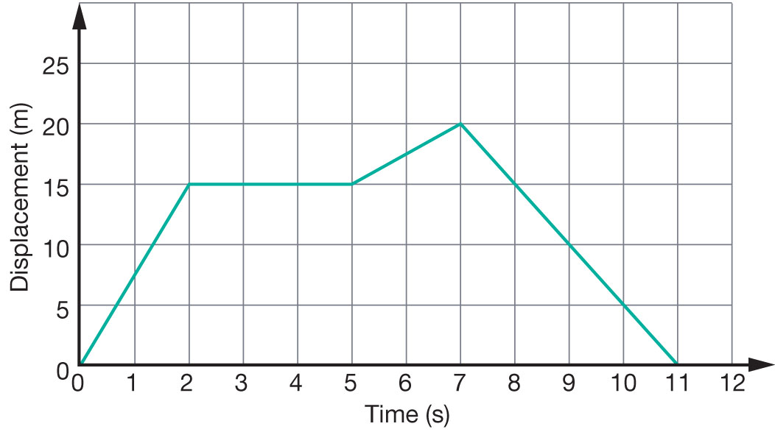

a Construct a velocity–time graph of the cat’s motion on the axis below.
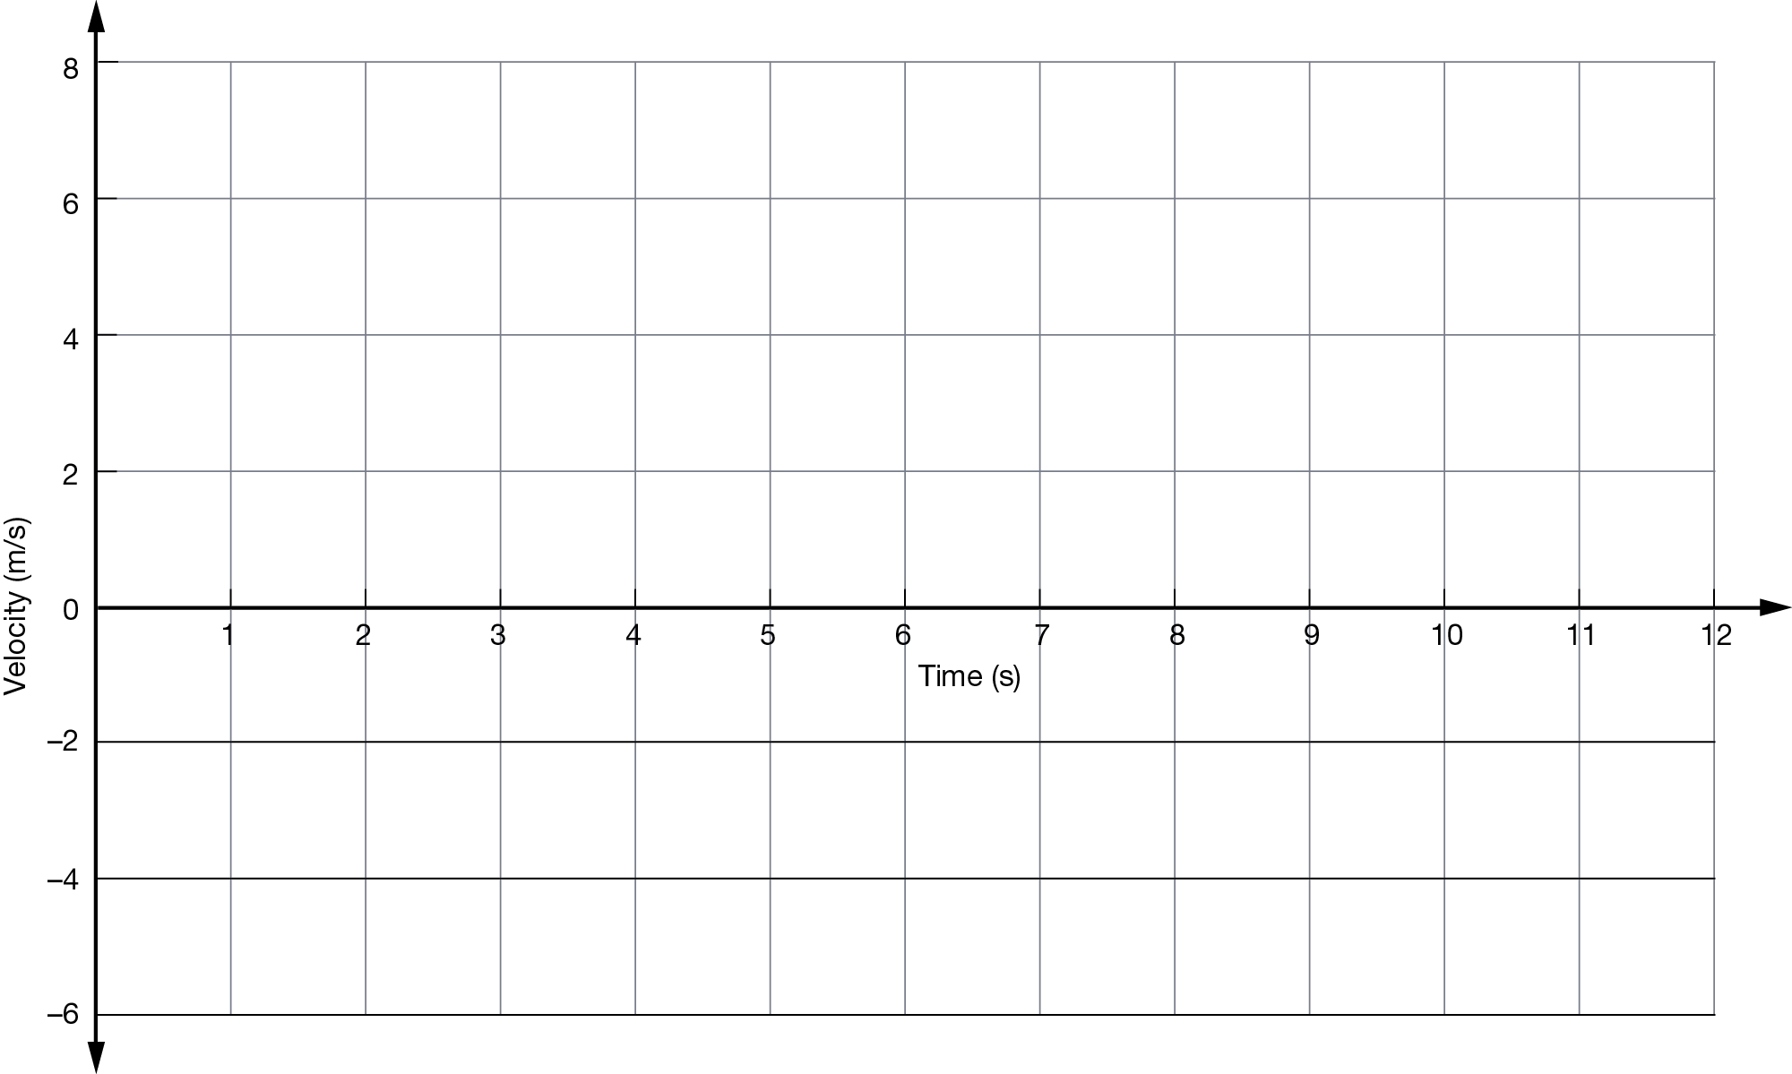
b Describe the motion of the cat as it runs along the laneway.

2 The graph below shows the motion of a cruise ship as it travels in a straight line route from the docks to its destination.
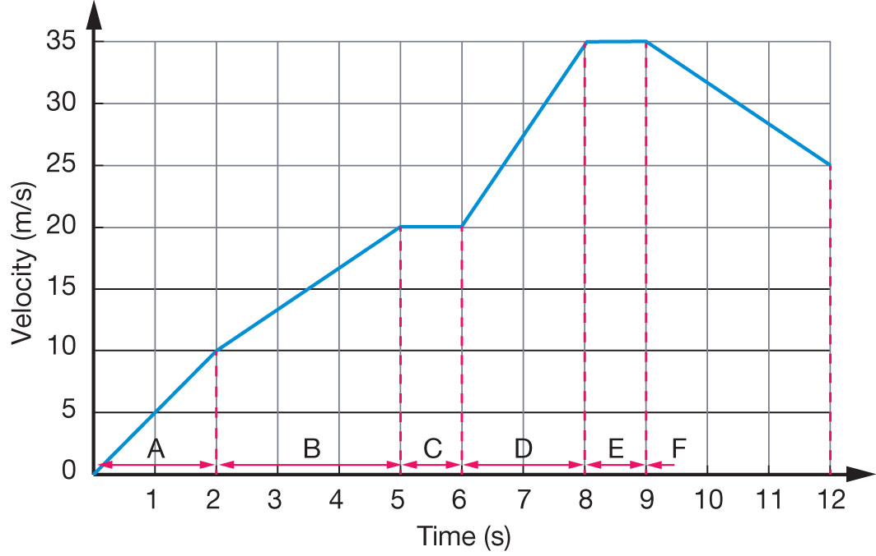
a Calculate the average acceleration of the ship in each of the sections marked A–F. Fill out your results in the table showing your working:

Section of motion | Average acceleration (m/s/s)
A
B
C
D
E
F

b Use your results from part a to construct an acceleration–time graph of the ship’s motion on the axes below:
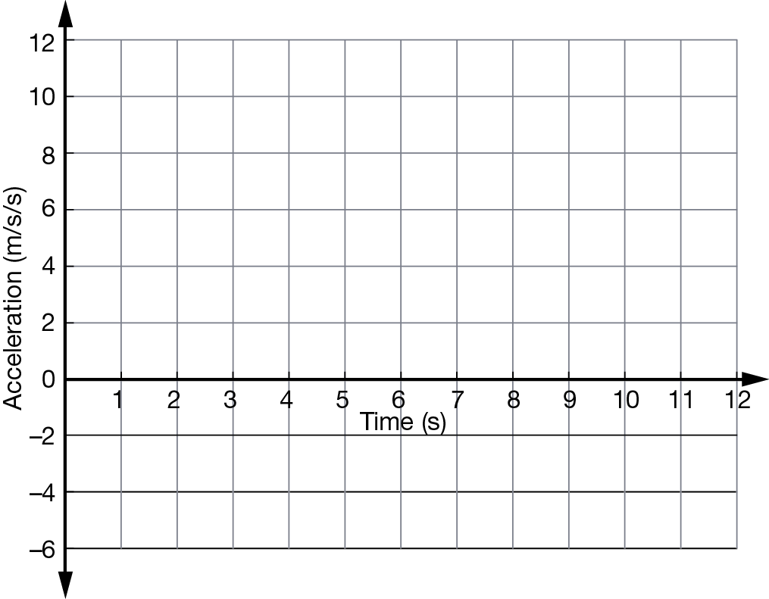
c Identify in which sections the ship is:
i speeding up:
ii slowing down:
iii travelling at a constant speed:
d Calculate the distance the ship sails in the first 5 seconds of its journey.

